Group 06 – Project Retrospective:

# Preface:

As of the 17th of September 2025, we have divided our Project into two halves, three people per half, along the Front-End back-end split for our deliverables for Sprint 2 & 3 to the OI. By Mondary 15th of September, we had finally got functional access to the UWA Research Repository API and before that had a Front-End concept designed and made in Figma, which we developed on to the day of this Report.

# The Front End:

This is the current front-end design deployed in a Flask framework temporarily (standing in to simulate the final Sitecore framework it will be deployed under).

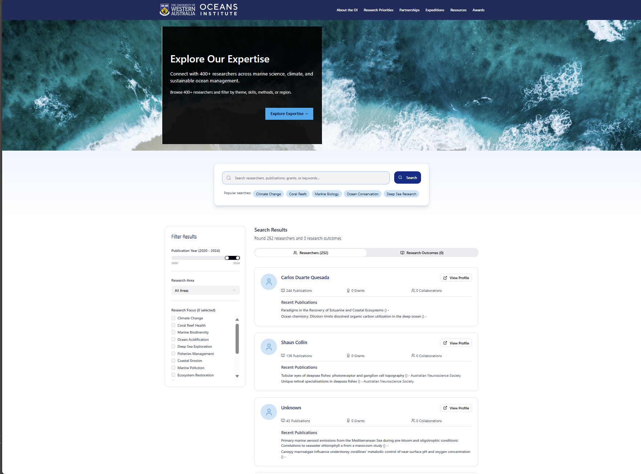

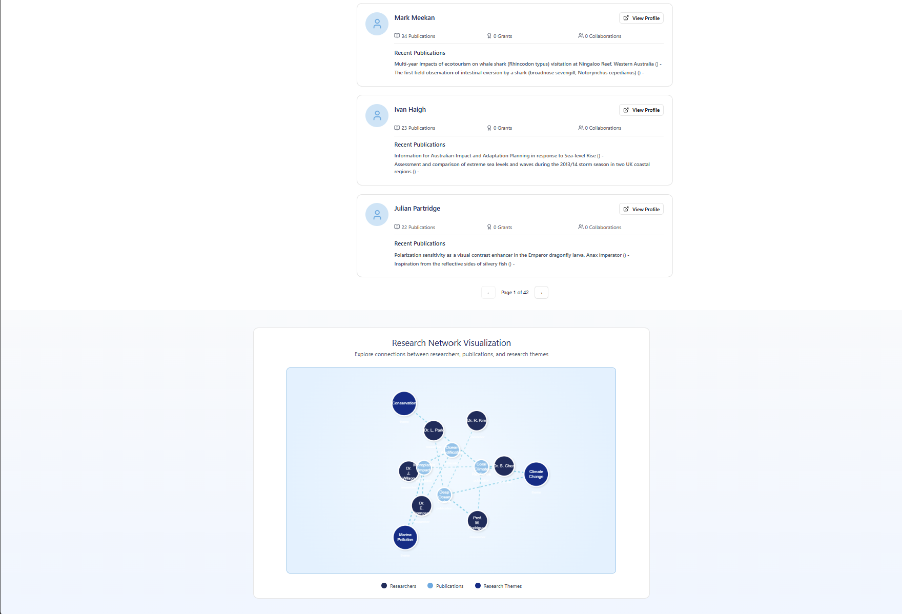

**What has been accomplished so far:**

This is currently implemented as a live front-end implementation of site using Vite with a Flask backend which serves website with research data through API calls.

* Front end interacts with SQL same database that contains real filtered OI member data and displays it. The database mimics our final Neo4j database allowing for a smooth transition when ready.
* Current web page supports all basic functionality that makes the website viable for its intended purpose i.e. activities such as filtering results by themes, searching research and outputs by name, related grants, and collaborators (assuming complete database).
* The codebase is organized into functional components structured in a way that allows ease of portability but also flexibility as we move forward and transition from a functional foundation into a more well-rounded solution. Shifting focus to additional features that increase engagement, aesthetic, and user experience instead of basic function.

**What remains to be implemented**:  
The front end still lacks many potential and planned features that can elevate the site and potential engagement but our current approach is to stabilize our source of truth, which is the final database schema and content, ensuring that we can model and populate data accurately and reliably before we expand features on the front end, in hopes to mitigate the risk of building a front end that the back end cannot support. This has resulted in a current bottleneck for the features of the front due to outstanding dependencies:

* The link between Research Grants, OI Members/Researchers and Research Outcomes
* The details for grant and linking that to tags
* Tags for Research Outcomes and Publications

These are currently underway and are not done purely due to time constraints, not feasibility, but need to be resolved before implementing additional front-end features so we can determine what features exactly we can add with the data and links we have.

There also remains the issue with the view profile solution, as external links remove from a unique Ocean Institute experience, leaving us with the only option of providing a view internally. This inherently comes with a different set of technical issues for providing as much information as possible but also balancing that with the sheer number of requests and data that might be needed while maintaining a smooth and quick user experience. So, we still need to plan and design a specific solution for this Additional Feature Request (i.e. this feature was not covered in the original scope of work document from Sprint 1) that provides the best outcome that satisfies client needs as stated in the Minutes of the Project Retrospective Meeting we had with the client.

# The Back End:

**Week 6-7: Database Design and Initial Data Extraction:**

During Weeks 6 and 7, the back-end team focused on designing the database structure, including the entities and their relationships. While a rough version of the Entity Relationship Diagram (ERD) was developed, the team encountered delays with the API, which impacted the ability to extract data as initially planned.

To progress, the backend team opted to manually extract data from the PURE system. This allowed us to gain a better understanding of the relationships within the data and how it could be mapped to our ERD.

The V1 version is shown below:

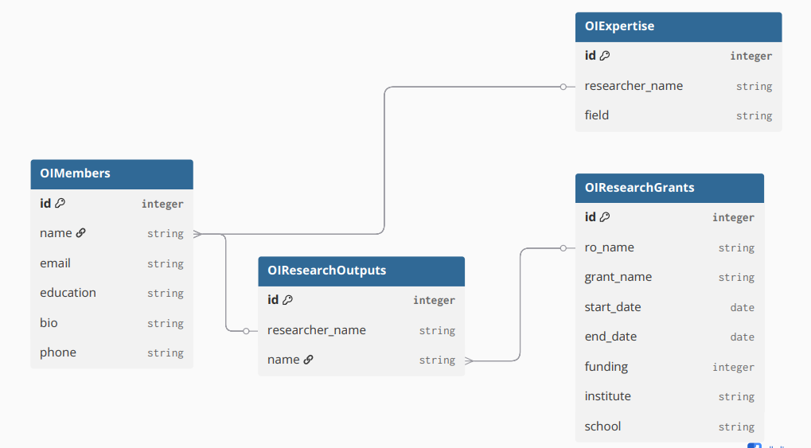

**Week 7: API Integration Challenges**

By the end of Week 7, the back-end team received the API from the client and Ocean Institute staff. However, we faced challenges in understanding the schema of the data provided by the PURE Repository. This required additional time and effort to analyse and become familiar with the API structure.

**Week 8: Data Extraction and API Analysis:**

At the start of Week 8, the backend team gathered to analyze the API and began extracting data using the API key provided by the client. To streamline this process, we developed multiple Java scripts to target specific API endpoints. Each script was designed to extract data from a different endpoint within the PURE Repository.

**Week 8: Next Steps and Current Progress:**

As of Week 8, the backend team is focused on importing the extracted data into Neo4j. The next steps involve filtering and structuring the raw data to meet the client’s specific requirements. Once this is done, we will establish the relationships between the data endpoints within Neo4J, providing the frontend team with a structured dataset that can be used for the search engine functionality.

# The Plan Forward:

As we discussed in the Project Retrospective with the Client in the #4th Client Meeting which took place between 12:30PM and 1:15PM on the 17th of September, given we only had 3 days' worth of time due to substantial and unforeseen delays acquiring functioning API Keys versus what we had planned at a high level timeline wise in the Scope of Work Document from Sprint 1, we would endeavour to finish as many if not all the major features on both ends as they have been detailed so far by the time of the 5th Meeting with the Client set sometime between Monday and Friday of Week 9 – at which point we would as part of Sprint 3 providing source and compiled Front End files so the Client can with our advice deploy it into Sitecore live and use the technical feedback from that process to apply required bugfixes and feature changes to accommodate the final installation process & creating and improving the connection with the back end deployments to the Azure environment when the back end team finishes with the designing and testing of the final Neo4J schema and model to deploy on that VM. Once all that is done it will be bugfixing/technical advice till the October 13th handover.